Farm Management System

1. INTRODUCTION

1.1 Project Overview
The Farm Management System (FMS) is a cloud-based agricultural management application developed using the Salesforce platform. The system is designed to digitalize and simplify farm-related operations by managing important agricultural data in a centralized environment.
The application allows farmers, farm managers, and agricultural organizations to store and manage information related to farms, crops, farmers, and buyers. It helps users track farming activities, crop production, and sales records efficiently.
The system also provides real-time insights through reports and dashboards, which help users analyze agricultural performance and monitor farm activities effectively. By using this system, farmers and managers can reduce manual record-keeping, improve data organization, and make informed decisions based on accurate data.
Overall, the Farm Management System aims to improve farm productivity, operational efficiency, and transparency in agricultural management through digital technology.

1.2 Purpose
The main purpose of this project is to develop a digital platform that helps farmers and agricultural managers manage farm-related data effectively.
The key objectives of the system include:
- Digitizing agricultural data management to replace traditional manual record keeping.
- Improving data accuracy and accessibility by storing information in a centralized database.
- Automating record handling such as crop records, farmer details, and buyer transactions.
- Enabling real-time monitoring of farm activities through reports and dashboards.
- Supporting data-driven farming decisions using analytical insights.
- Enhancing productivity and transparency in farm operations.
2. IDEATION PHASE
2.1 Problem Statement (Customer Problem Statement Template)
2.2 Empathy Map Canvas
Target Users:
● Farmers
● Farm Managers
● Buyers
● System Administrators
Empathy Analysis
● Think & Feel: Need accurate and timely farm data
● Hear: Feedback from agricultural officers
● See: Registers, paper files, spreadsheets
● Say & Do: Enter records manually
● Pain: Data loss, errors, delays
● Gain: Automation, fast reporting
3.REQUIREMENT ANALYSIS PHASE
3.1 Customer Journey Map
Stages:
1. Login
2. Access Farm Management App
3. Enter Farm and Crop Data
4. Register Farmers and Buyers
5. Generate Reports
6. Analyze Results
7. Decision Making
4. PROJECT DESIGN PHASE
4.1 Problem–Solution Fit
The FMS replaces manual farming records with automated data management.
Cloud storage prevents data loss, dashboards improve analysis, and real-time
reports eliminate delays. This ensures accurate and timely agricultural insights.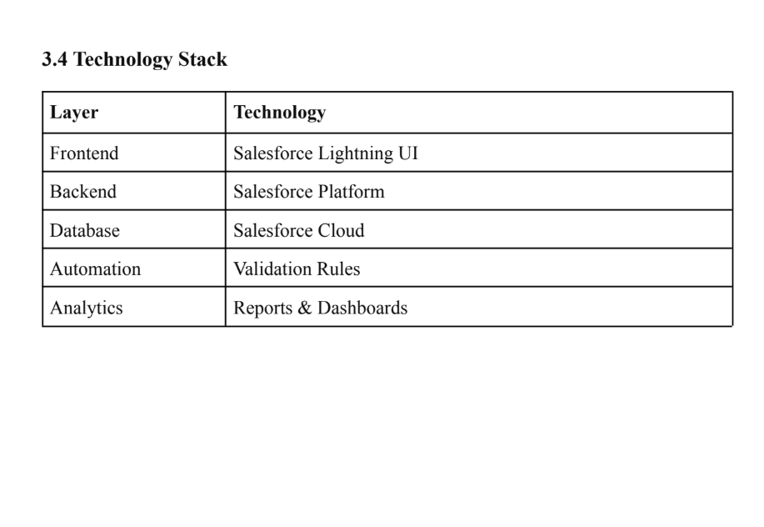
Activity1:
Creating a Salesforce Developer Org:
A Developer org has all the features and licenses you need to get started with Salesforce.
1. Search Developer.salesforce.com/signup
2. Enter the following details like First name, last name, Email, Role, Company,
Country/Region, Postal code, and Username must be unique.
3. Click sign me up, after a few min you will reserve a mail salesforce org and by using
the verify account link you can create your new password.
4. Click save.
5. Search login.salesforce.com

6. By using username and password you can into the Salesforce org. The homepage will
appear below
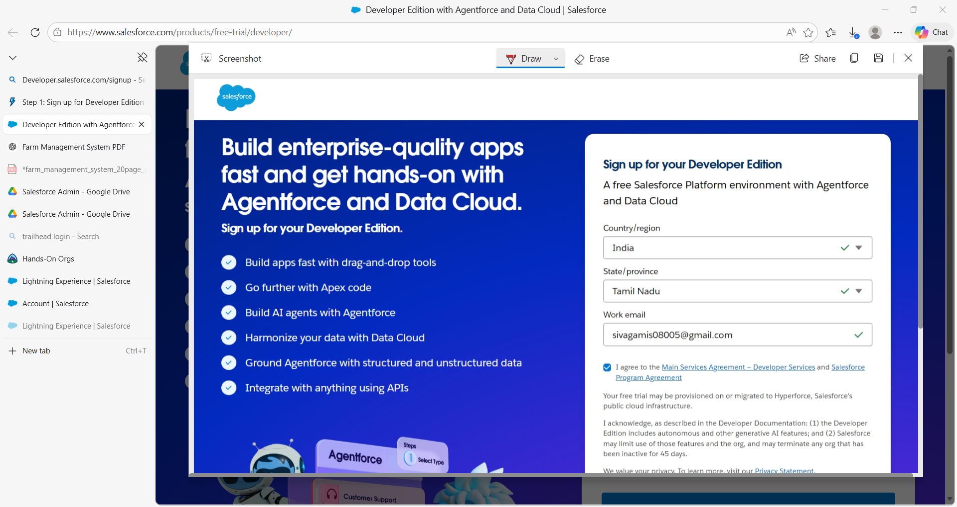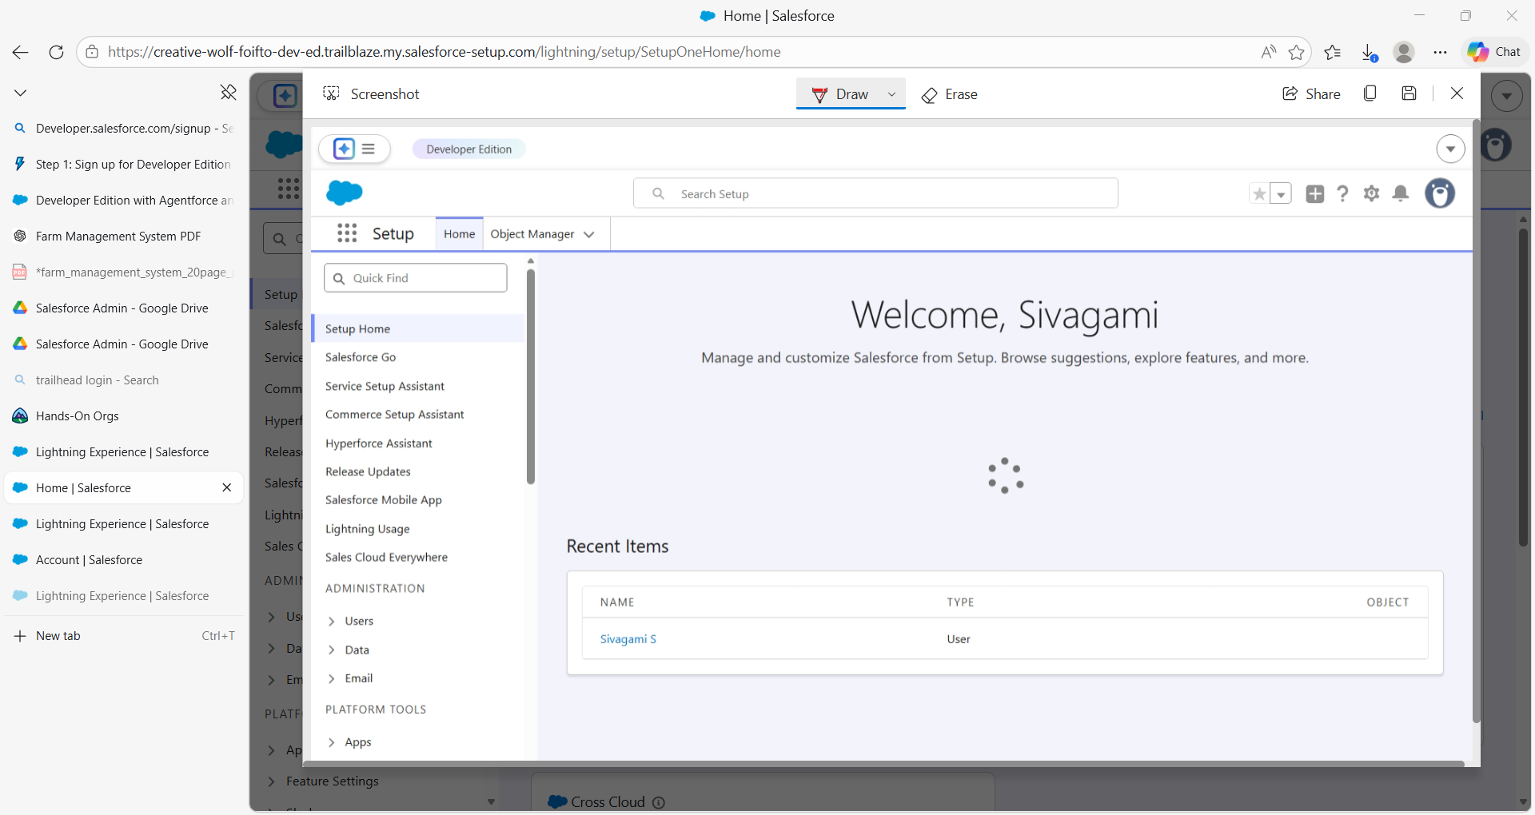
Milestone 2-Object:
What is an object?
Salesforce objects are database tables that permit you to store data that is specific to an
organization. It consists of fields (columns) and records (rows).
In This Application We Use 4 Custom Objects:
1.Farm
2.Crop
3.Farmer
4.Buyer
Activity 1:
Create a custom object for Farm:
To create a custom object, follow these steps:
1. From setup click on object manager.
2. Click create, select custom object.

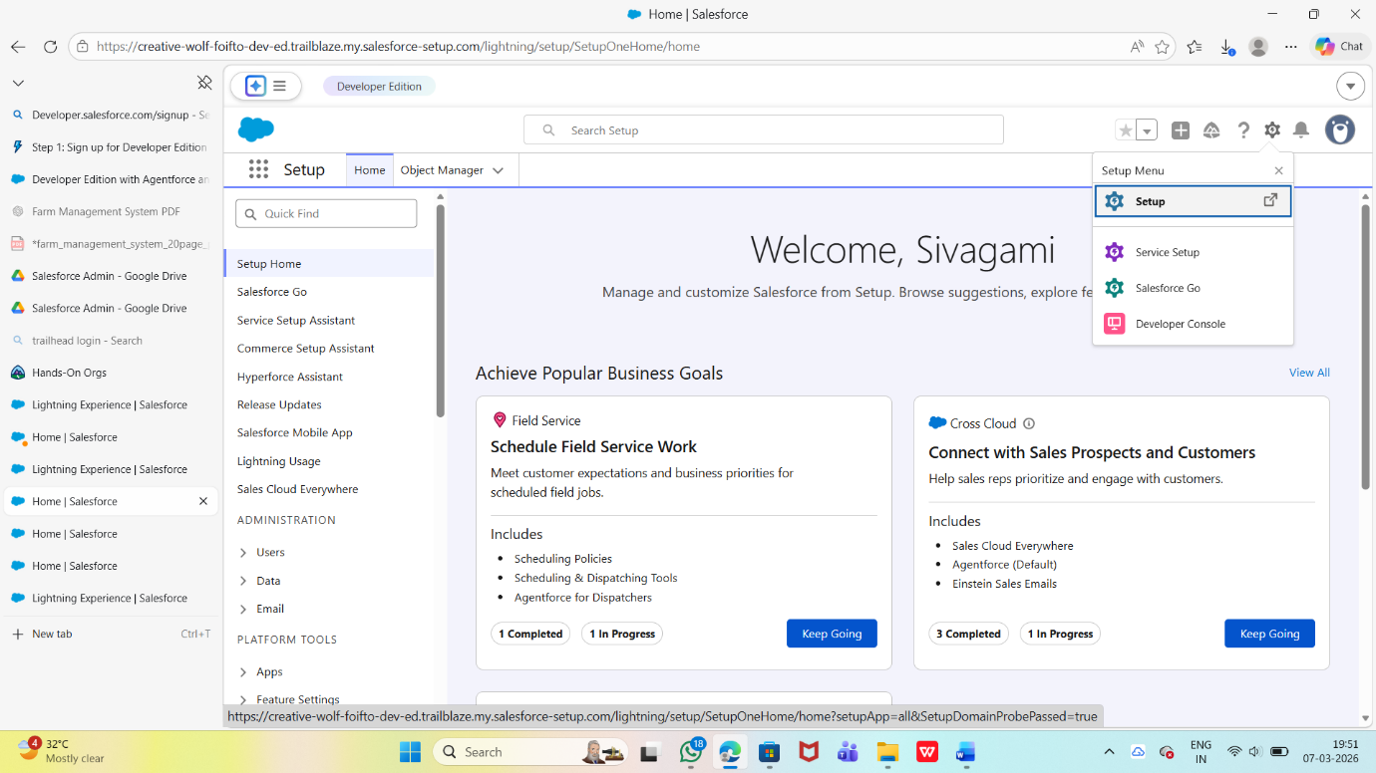
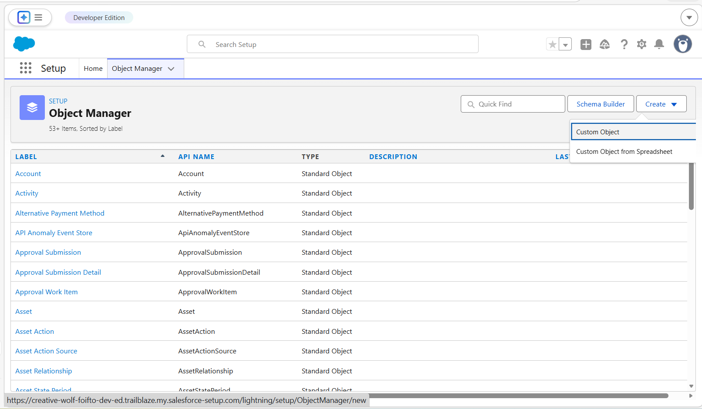
3. Fill in the label as " Farm ".
4. Fill in the plural label as " Farms".
5. Record name: Farm Name"
6. Select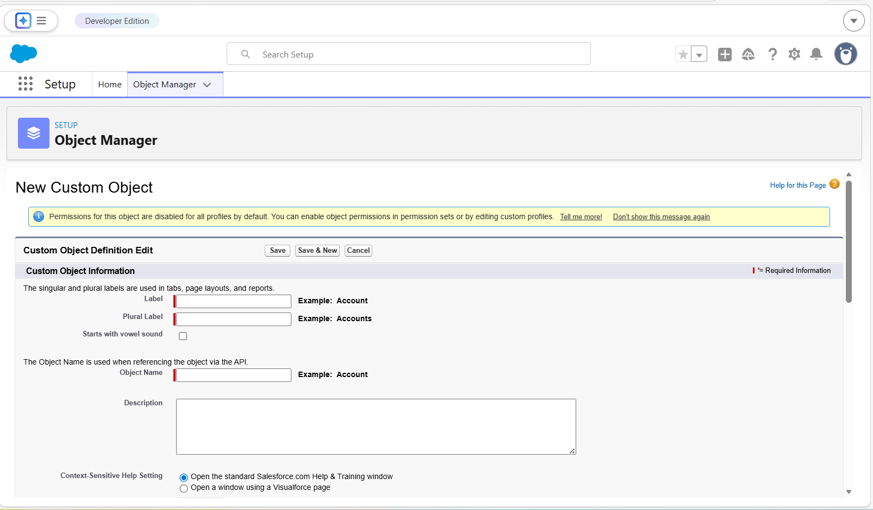 the data type as "Text".
+
7. In the Optional Features section, select Allow Reports and Track Field History.
8. In the Deployment Status section, ensure Deployed is selected.
9. In the Search Status section, select Allow Search.
10. In the Object Creation Options section, select Add Notes and Attachments related list
to default page layout.
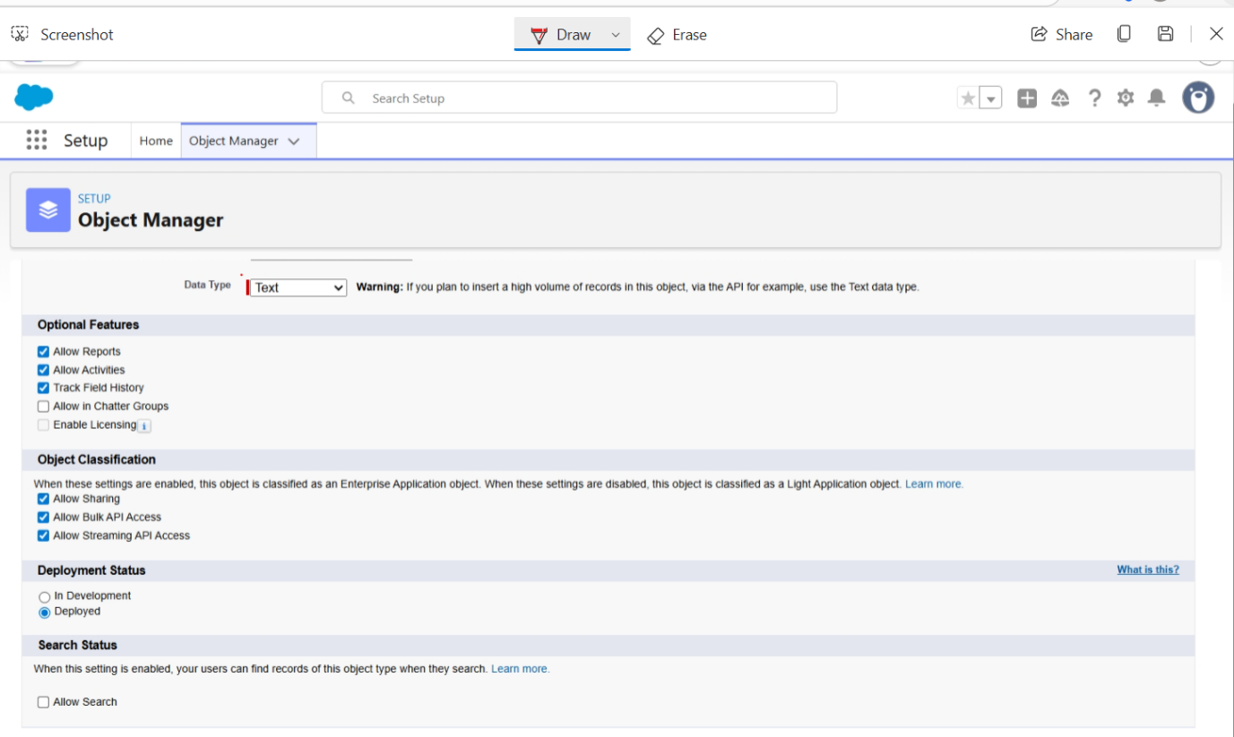
11. Leave everything else as is, and click Save. 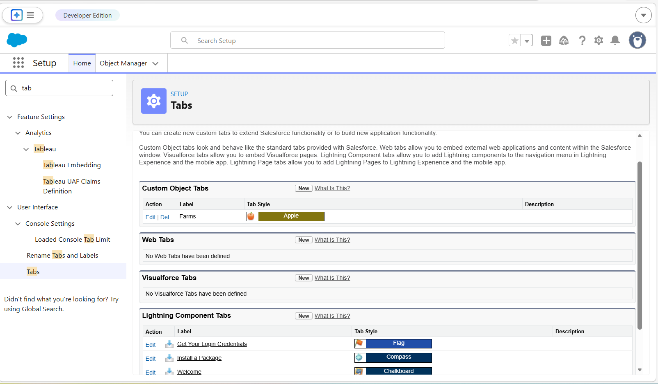

3. For Object, select Farm.

4. For Tab Style, select any icon.
5. Leave all defaults as is. Click Next, Next, and Save.
Activity 2:
Creation of Crop tab:
Now create a custom tab.
1. Click on Home tab, enter Tabs in Quick Find and select Tabs.
2. Under custom object tabs, click New.
3. For Object, select Crop.
4. For Tab Style, select any icon.
5. Leave all defaults as is. Click Next, Next, and Save.

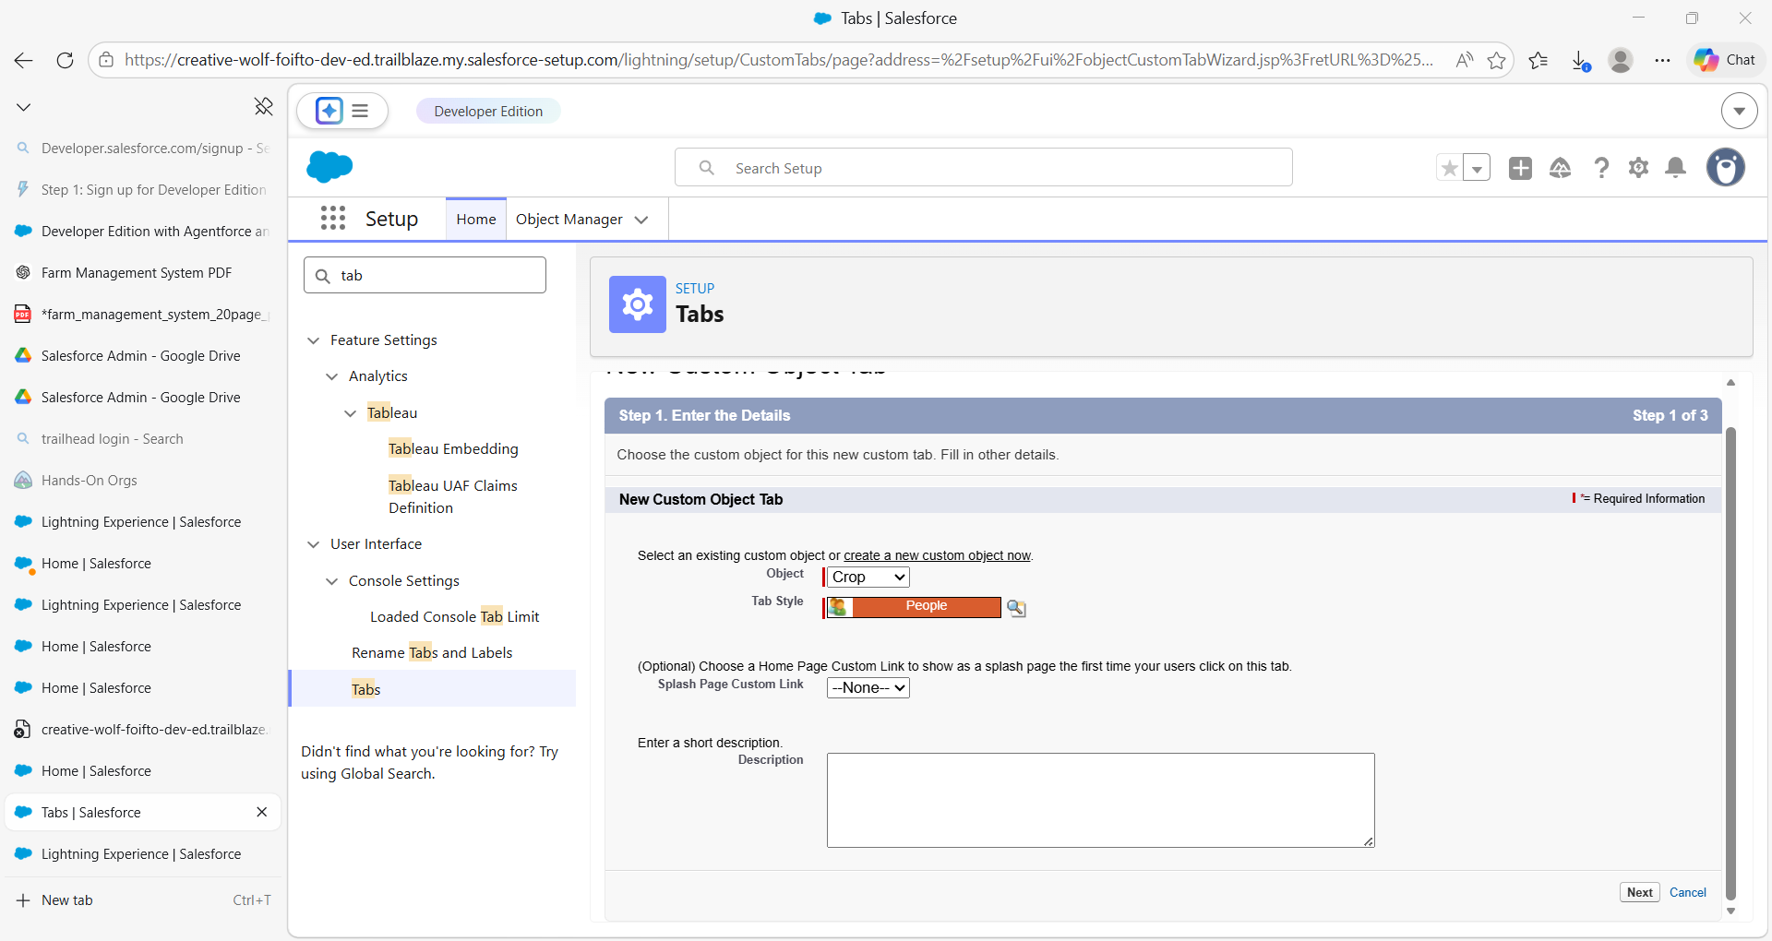Activity 1:Create the Farm Management System app
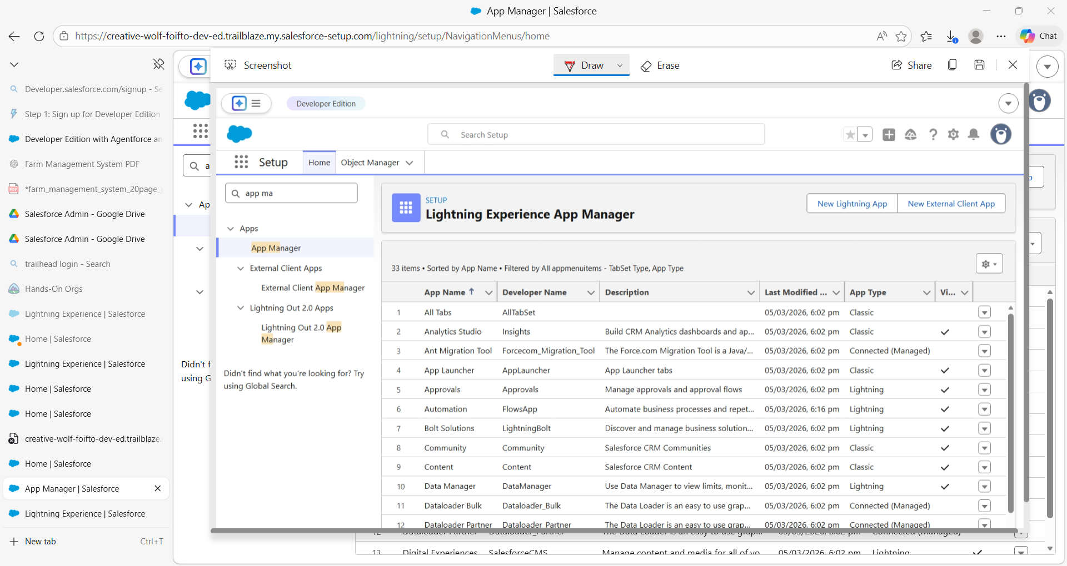

Activity 2:
Creation of fields for the Crop objects:
1.Choose Data type As a text,Enter Field Label name (Crop Name),Next save. 2.Select
Data type as date ,Enter Field label (Planting Date),then save .
3.Again we select data type as a date,Enter field labe (Harvest date),save
4.Next We Create Lookup relationship on crop object realted to Farm Object.
5.We select adata type as currency,Enter field Label (Actual Yield), Next Save it.
6.Select Data type as a Number,enter Field Label (Total Acres Harvested),Enter
Maximum Length(20) and save.
7.Now We create Formula Field For That Select data Type As a Formula,Click Next.

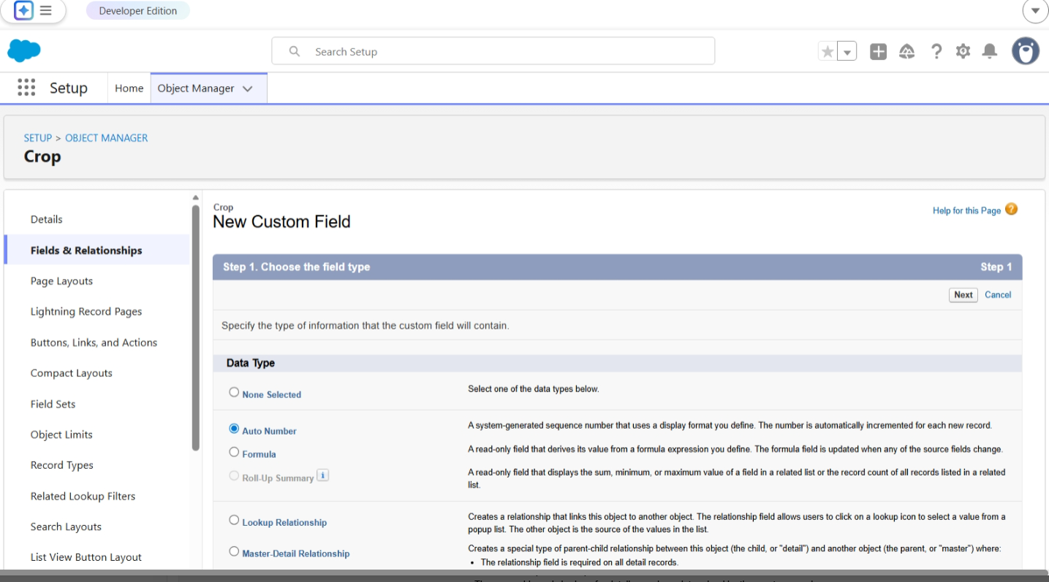Milestone 6- Profile:

What is a profile?
A profile is a group/collection of settings and permissions that define what a user can doIn salesforce. A profile controls “Object permissions, Field permissions, User permission Tab 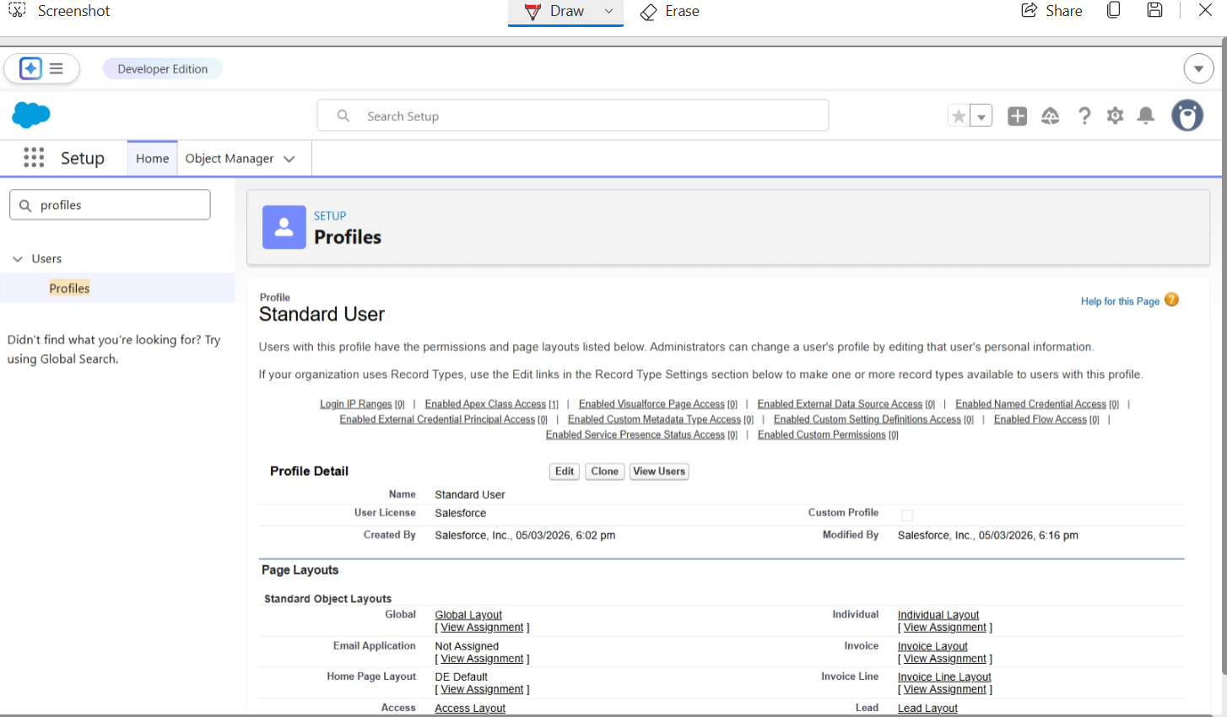settings, App settings, Apex class access, Visualforce page access, Page layouts, Record
Types, Login hours & Login IP ranges.
A profile can be assigned to many users, but user can be assigned single profile at a time.
Activity 1:
Create a custom profile:
1. From setup , enter profiles in Quick Find box
2. Select profiles (Standard user).
3. Click clone.
4. For Profile, enter Sales Department.
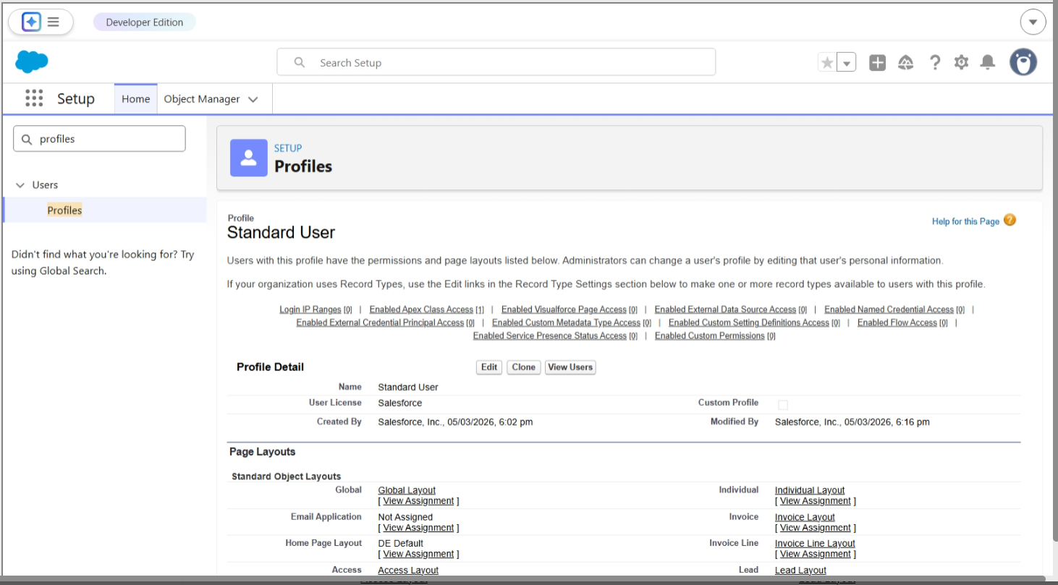
Milestone 7- Role
In Salesforce, roles are used to determine which users have access to certain data and
functions within the system. They are also used to define the reporting hierarchy within
an organization. Users with higher roles have greater access to data and more control
over the system.
Activity-1
Creation of role
1. From the Quick find box search for the role and click on the roles option
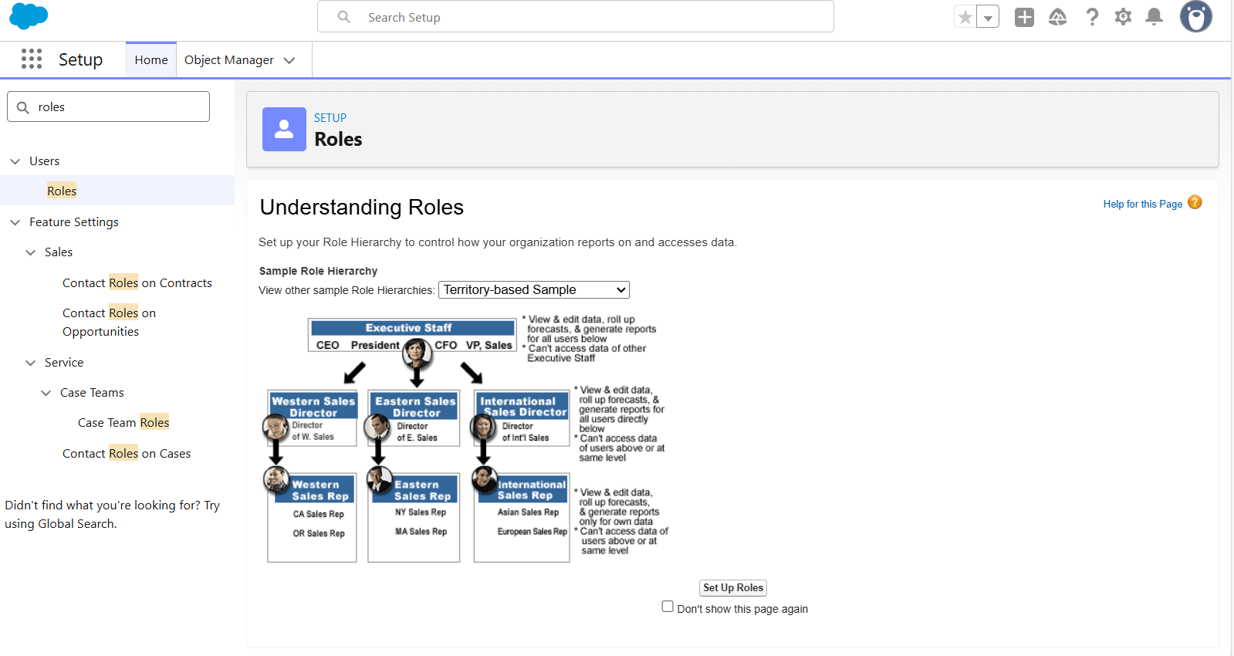What are Reports?
A report is a list of records that meet the criteria you define. It's displayed in rows and
columns, and can be filtered, grouped, or displayed in a graphical chart. Every report is
stored in a folder. Folders can be public, hidden, or shared, and can be set to read-only or
read/write.
Activity 1:
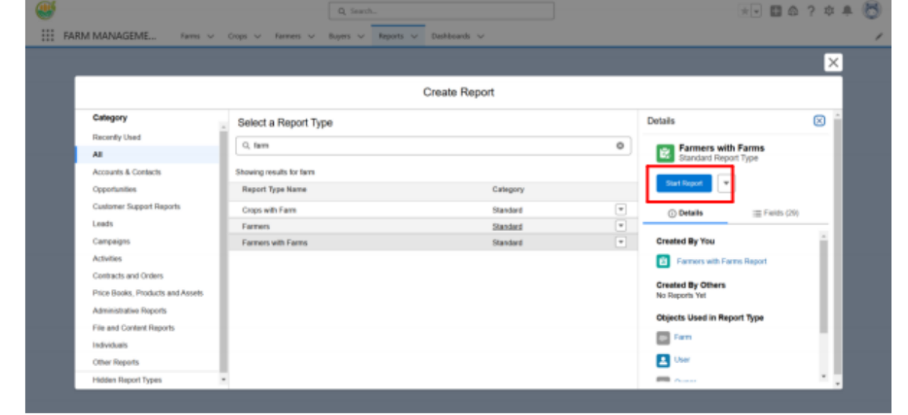Create a report that displays rating of the account and which has type and account name.
1) Click on app launcher search for reports.
2) Click on the new report and select the category has Farmer with Farms.
3) In the details section select the option start report.
4) In Outline Click on Column Select Which Field you want to display in the Report.
5) Click Group,Select Which Fields You Want to Group.
6) Save the report by giving label name(Farmer with Farms) and save the folder as a
public folder and save the report.

Advantages
• Easy record keeping
• Time saving
• Better decision making
• Improved productivity

Limitations
• Requires internet access
• Basic version without IoT sensor

Future Enhancements:
Integration with IoT sensors, weather prediction, and mobile app support

Conclusion :
The Farm Management System provides an efficient solution for managing agricultural operations digitally

THANK YOU

